Project Planning Phase
Project Planning Template (Product Backlog, Sprint Planning, Stories, Story points)

Date | 30 September 2026
Team ID | MKU201Team56ab4dc836f290be8a6b49be8
Project Name | Import Data Using Transform Maps (ServiceNow Micro Project)
Maximum Marks | 5 Marks

Product Backlog, Sprint Schedule, and Estimation (4 Marks)
Use the below template to create product backlog and sprint schedule
Sprint | Functional Requirement (Epic) | User Story Number | User Story / Task | Story Points | Priority | Team Members
Sprint-1 | Data Preparation | USN-1 | Prepare the employee spreadsheet (5 columns) and save as .xlsx | 2 | High | C. Mallika
Sprint-1 | Table Creation | USN-2 | Create custom table Employee Test (u_employee_test) | 2 | High | K. SHARMILA JOTHI
Sprint-1 |  | USN-3 | Add five String fields to the Employee Test form | 3 | High | S. SRIVARSHINI
Sprint-1 | Import Set | USN-4 | Create Employee Import table using Load Data | 3 | High | S. SRIVARSHINI
Sprint-2 | Transform Map | USN-5 | Create Transform Map 'Sample Spreadsheet Import' | 3 | High | T. VIJAYADHARSHINI
Sprint-2 |  | USN-6 | Map the five source fields to target fields | 3 | High | R. MAHAVEERALASKHMI
Sprint-2 |  | USN-7 | Run Transform and validate records | 2 | High | R. MAHAVEERALASKHMI
Sprint-2 | Duplicate Handling | USN-8 | Enable Coalesce on Employee ID | 2 | High | K. SHARMILA JOTHI
Sprint-3 | Re-import | USN-9 | Import updated and new data; verify updates and inserts | 2 | Medium | C.MALLIKA
Sprint-3 | Reports | USN-10 | Create Employees by Department, Employees by Location and Employee List reports | 3 | Medium | T. VIJAYADHARSHINI
Sprint-3 | Dashboard | USN-11 | Create Employee Analytics Dashboards | 3 | Medium | T. VIJAYADHARSHINI
Sprint-3 |  | USN-12 | Add all three reports to the dashboard and verify | 2 | Medium | R. MAHAVEERALASKHMI

Project Tracker, Velocity & Burndown Chart: (4 Marks)
Sprint | Total Story Points | Duration | Sprint Start Date | Sprint End Date (Planned) | Story Points Completed (as on Planned End Date) | Sprint Release Date (Actual)
Sprint-1 | 10 | 3 Days | 21 Sep 2026 | 23 Sep 2026 | 10 | 23 Sep 2026
Sprint-2 | 10 | 3 Days | 24 Sep 2026 | 26 Sep 2026 | 10 | 26 Sep 2026
Sprint-3 | 10 | 3 Days | 27 Sep 2026 | 29 Sep 2026 | 10 | 29 Sep 2026

Velocity:
Sprint duration = 3 days; total story points = 30 across 3 sprints.
Velocity = 30 / 3 = 10 story points per sprint.
Average velocity per day (AV) = 10 / 3 ≈ 3.33 story points per day.

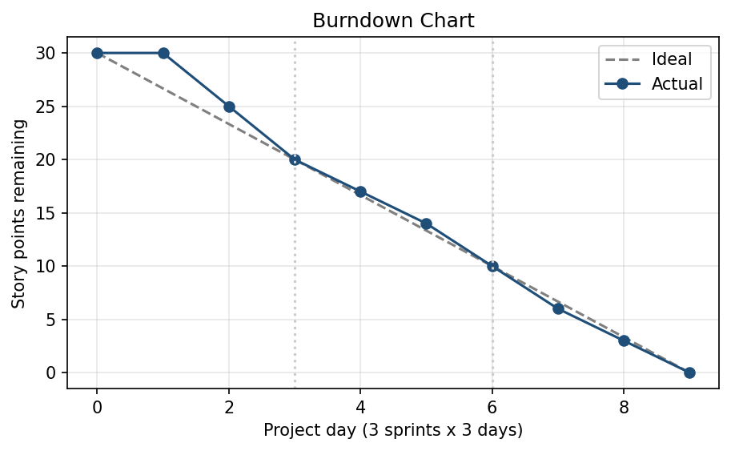

Burndown Chart:
A burn down chart is a graphical representation of work left to do versus time. It is often used in agile software development methodologies such as Scrum. However, burn down charts can be applied to any project containing measurable progress over time.

https://www.visual-paradigm.com/scrum/scrum-burndown-chart/
https://www.atlassian.com/agile/tutorials/burndown-charts

Reference:
https://www.atlassian.com/agile/project-management
https://www.atlassian.com/agile/tutorials/how-to-do-scrum-with-jira-software
https://www.atlassian.com/agile/tutorials/epics
https://www.atlassian.com/agile/tutorials/sprints
https://www.atlassian.com/agile/project-management/estimation
https://www.atlassian.com/agile/tutorials/burndown-charts

